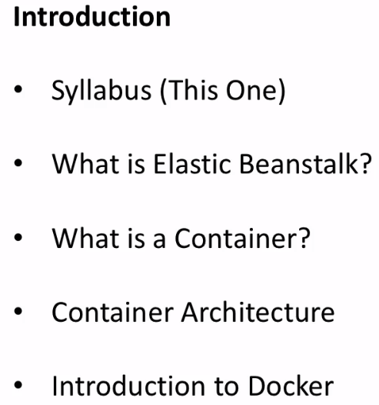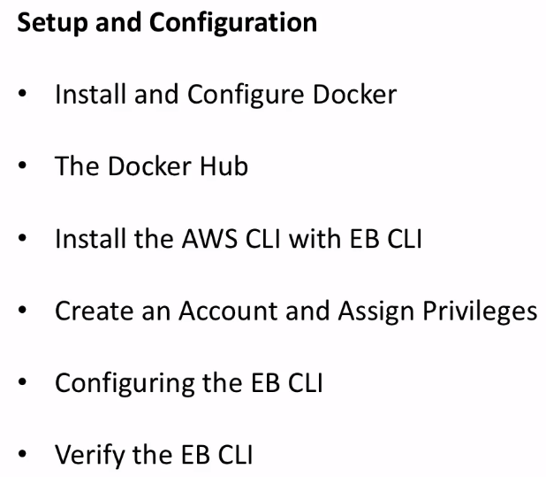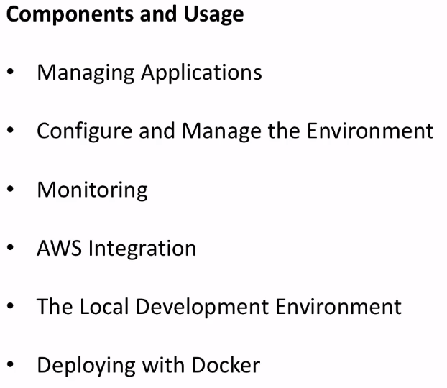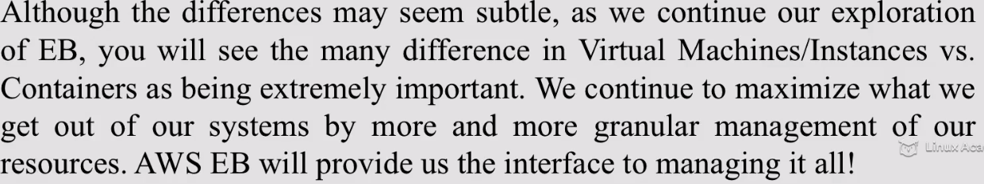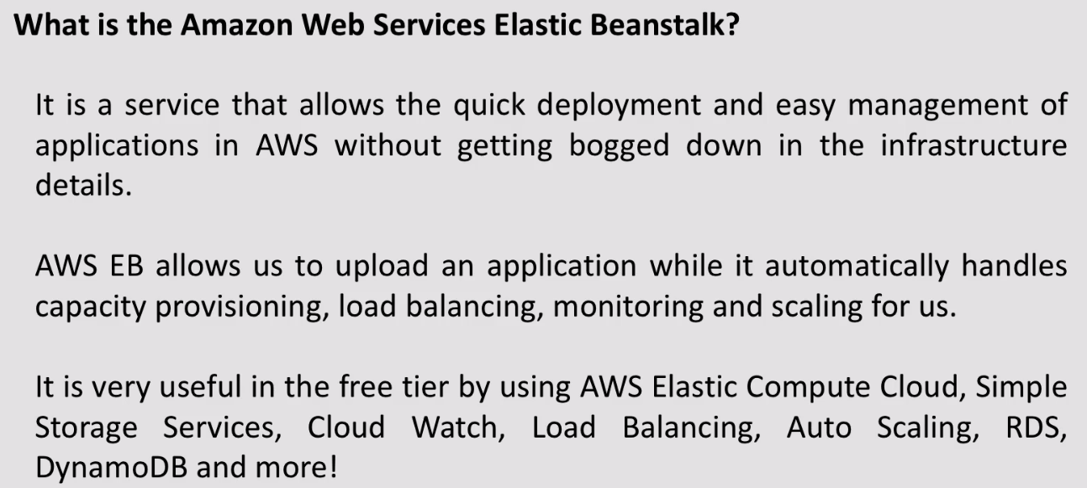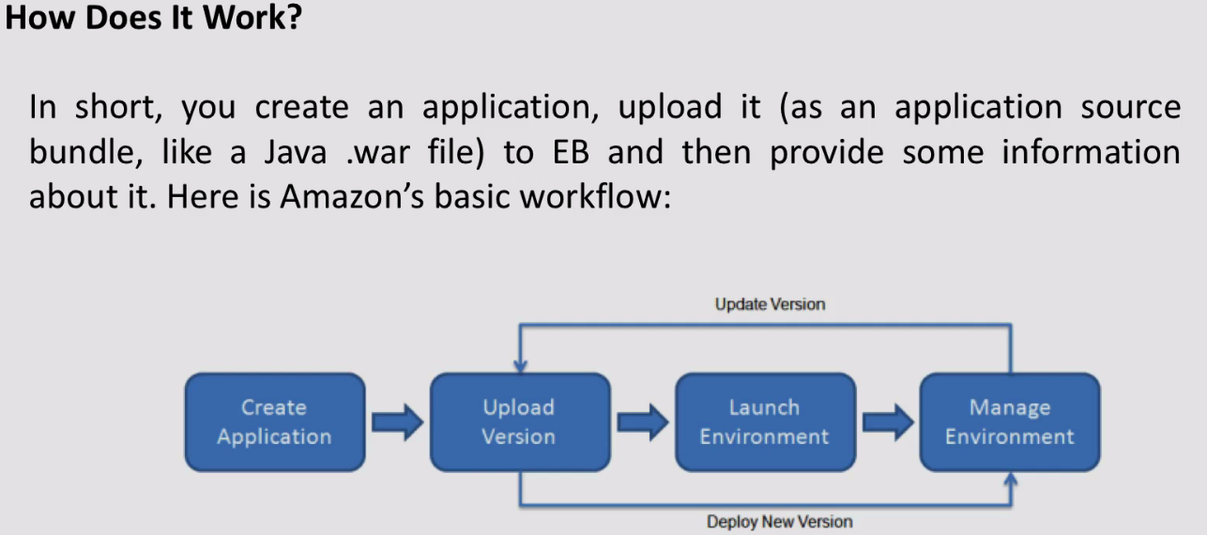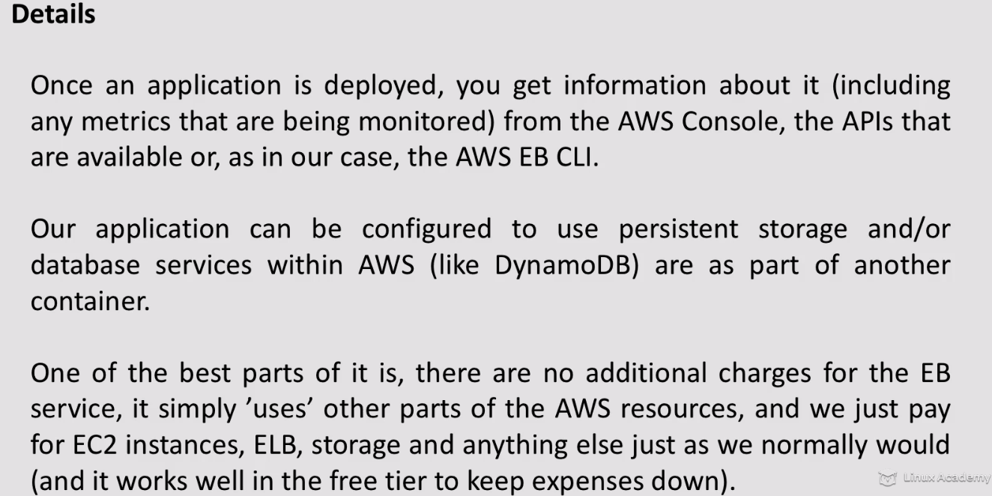

**Installing the AWS CLI and EB CLI Tools**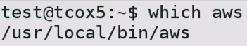



**67-541-5 - Elastic Beanstalk Accounts and Groups**

**AWS website: **

**Don’t run anything using root**

**On enterprise env. We have 100’s of users where it is convenient to role, assigning appropriate access to role.**

**Add users and add users to that particular a/c. Make changes to group, and that will be applied equally to all users of that particular role.**

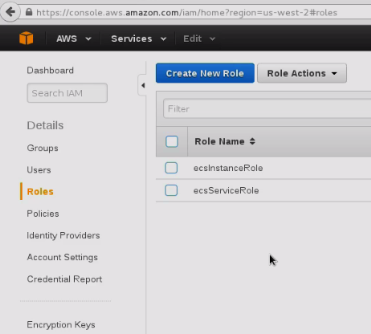

**Create role:**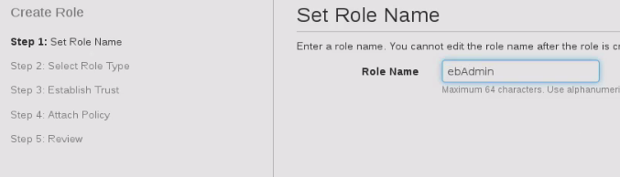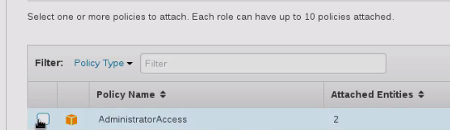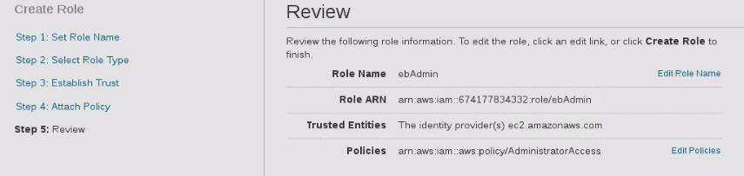

**So any body added to ebadmin is an administrator.**

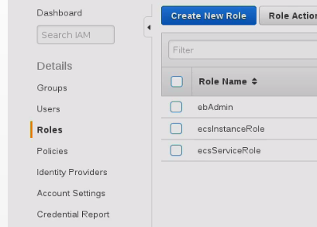

**Create User**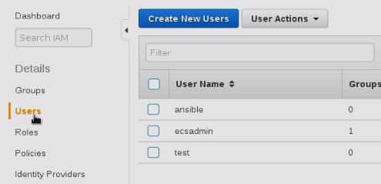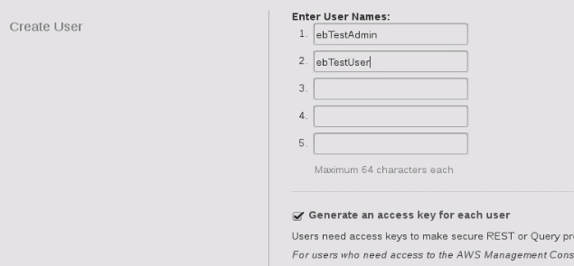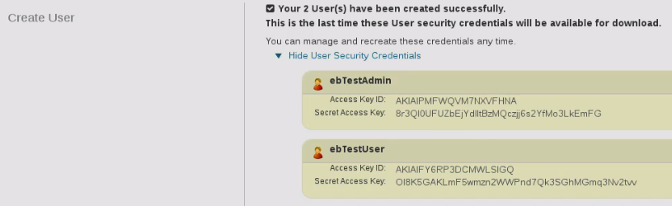

**67-542-1 - Elastic Beanstalk_ Our First App - Using the Wizard**